The History of Go Rules
by Chen Zuyuan 陈祖源
© 2011

Chen Zuyuan has published two monographs: “Study of Rules of Go “(2000), "History of Changes in the Rules of Go” (2007); and - in China's Weiqi Tiandi and other publications - more than 35 feature articles. He collaborated in formulating the 2002 edition of the rules of go in China, and in 2008 drafted the go rules of the 1st World Mind Sports Games for the International Go Federation.

The most fundamental difference in the various present-day rules of go occurs in the scoring of the game: territory scoring (Japanese-style) or area scoring (Chinese-style). Although we all know that territory scoring has logical flaws, it is still preferred by most people, because it is simple and practical. So people have tried to improve it, but in reality the result of the improvements has been that territory scoring is eventually turned into area scoring, as in AGA rules. Naturally this is what people who prefer territory scoring do not want, and they hope that territory scoring can be improved in ways separate from area scoring, and that territory scoring can exist in parallel with, not be dependent on, area scoring. Although satisfactory results have not yet been achieved, people still look forward to it, especially of course people in the Nihon Ki-in.
But can we change our thinking? We know Japanese go came from China. In 1727 the Japanese go world endorsed a document in which there is a paragraph: “Go was invented by the Emperors Yao and Shun, and introduced to us by the Lord Kibi.” Yao and Shun were ancient Chinese emperors. Kibi no Makibi （695－775） was a Japanese scholar and nobleman during the Nara period. In 716 he travelled to China to study, and returned to Japan in 735. Actually, Go may have reached Japan even earlier. Whatever, there is consensus in the Japanese go world that Japanese go was introduced from China. Of course Japanese go rules also came from China, and ought to be the go rules of the Tang Dynasty. If we can work out what the go rules in ancient China were, especially in the Tang Dynasty, and how area scoring and territory scoring were introduced, used and changed, then find out the origin and the relationship between them, and then come back to look at the present rules of go, our understanding will be much deeper and much clearer.
Go rules in ancient times were always passed on by word of mouth, and were usually not clear, uncertain even. Go has had written rules only since the middle of the 20th century. In ancient texts we can find no descriptions of go rules apart from sometimes a word or two, and very vague at that. The ancient Chinese is also obscure, not only as regards the ancient calligraphy and grammar, but also as regards the specific go terms of ancient times. In addition, all the texts of ancient go that we can read have been adapted to modern publications, and so they could have inadvertently been changed and lost their original appearance. Sometimes the adaptation may have generated inaccuracies. The originals of the ancient texts, some more than a millennium old, have become valuable cultural relics, and direct use of the originals can face many difficulties. Knowledge of ancient go rules is therefore always unsure, for lack of evidence.
The author has conducted relevant studies, and the results were presented in a series of articles published in the Chinese magazine Weiqi Tiandi (The World of Weiqi [Go]) since 2005. A book, The History of Go Rules, a collection of the articles, was published in 2007. The article here is meant to be a summary of its main points in the hope that it will interest go enthusiasts outside China.
The most famous of all the ancient Chinese texts about go are the following three:
- Dunhuang Qijing 敦煌写本【碁经】 (handwritten Dunhuang Go Classic), from the Northern Zhou Dynasty, 557－581
- Wang You Qing Le Ji 忘忧清乐集 (Carefree and Innocent Pastime Collection), from the Song Dynasty, circa 1100, abbreviated here C&IP.
- Xuanxuan Qi Jing 玄玄棋经([Go Classic Offering the] Gateway to All Marvels), from the Yuan Dynasty, dated 1349 and abbreviated here GTAM
Dunhuang is in the north-west of China. It was a major point on the old Silk Road between ancient China and Central Asia. In 1900 a large number of ancient artifacts were discovered in the caves of Dunhuang. A large part of them, more than 6,000 items, were removed from Dunhuang in 1907 by the British explorer Marc Aurel Stein (1862－1943), and are stored in the British Museum. The Dunhuang Classic is one of them. Western people knew little about go (even by its Chinese name weiqi), and so the Dunhuang Classic was neglected for a long time, until microfilms of the Dunhuang artifacts made by the British Museum reached China in 1962. Then the go world discovered that there was indeed an ancient manual for go.
The manuscript was written in the Northern Zhou Dynasty (557－581), and is the oldest surviving go manual, about two hundred years earlier than the introduction of go into Japan. It has a very rich content, especially information about rules of go.
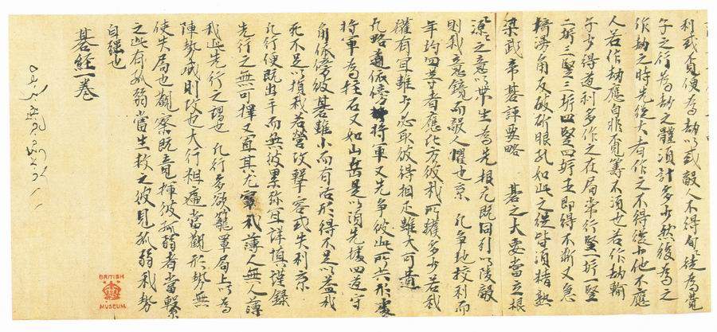
The following is a part of the Dunhuang Classic. In the bottom left there is a red collection seal of the British Museum.
Section of the Dunhuang Go Classic roll

But as the age of the Dunhuang Classic is nearly 1,500 years, the archaic Chinese is abstruse and very hard to understand. The archaeologist Cheng Enyuan has made a comprehensive study of it, and achieved good results. But, owing to the scope for different understandings of archaic Chinese and ancient go terms, the information on go rules has unfortunately been neglected.
The following sentence in the Dunhuang Classic (a photocopy of the original is shown at left) contains a wealth of significant information on rules. The Chinese text is:
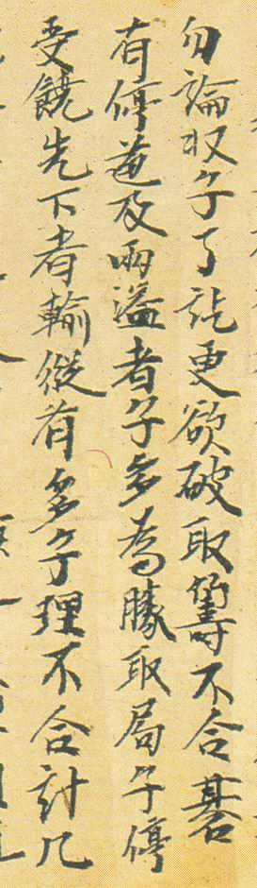
碁有停道及兩溢者，子多為勝。
If we translate it directly and literally into English, it reads, “Go has stop road and two overflowing, stones more is winner”.
This is just as obscure and incomprehensible in modern Chinese. To interpret it we have to refer to the later manuals C&IP and GTAM.
The latter half of the sentence is understandable, though: the player with more stones is the winner. The key to interpreting the whole sentence is the word "overflowing". C&IP and GTAM both mention and explain this word. GTAM says: “Overflowing means filled to capacity”, and C&IP says: ”Complete, with no overflowing”. Obviously, “overflowing” is an ancient go term. It means that stones have been placed everywhere they can on the board, and the next one will overflow, so that the game is over. “Two [or both] overflowing” means that both Black and White are "complete, with no overflowing". Therefore, the meaning of the sentence is: “Both sides place stones on the board until there is no place left to play, then stop, and the player with more stones is the winner.” This is stones scoring. In fact this rule was in use in China until the beginning of the last century. The only difference between it and the area scoring used today is that, for each string of living stones, there had to remain two eye points which had to be deducted when counting. If the basic eye points were completely filled, then the string of stones would die. The term "overflowing" in contrast to "complete" emphasizes that the two eye points cannot be filled.
But the board actually need not be completely filled. In fact the game can be ended and counted in a simplified way. Let us turn our attention to two of the other characters: “stop” 停 and ”road” 道. 道 is an ancient Chinese go term. It is defined as an empty point surrounded by stones of the same color, and roughly corresponds to the Japanese "moku" 目. 停 in classical Chinese may mean an equal division or bilateral coordination. So "stop road "means that the empty territories of both Black and White are equal. With equal empty territories both sides can fill in an equal number of stones. But they will not affect the count, so the side with more stones already on the board is the winner.
Therefore “stop road” is a simplification of “both overflowing”: if both players have equal empty territories, the one with more stones is the winner.
Of course, we can imagine another simplification: if both players have equal stones, the one with more empty territory is the winner. Although the Dunhuang Classic does not mention that, C&IP does.
C&IP is the oldest surviving printed go book, which was published in the Song (after 1100), and its original version still exists. It is kept in the National Library of China. It is an extremely important book in go history. In it there are some famous essays like The Go Classic in Thirteen Chapters 棋经十三篇, more than ten game records of national champions at that time, some ancient game records from the Han Dynasty to the Jin and Tang, and a lot of josekis and tsume-go problems. It comprehensively records and reflects a complete picture of ancient Chinese go. We can say that C&IP gives us the most comprehensive and profound understanding of the game of go in ancient China. C&IP is an ancient encyclopedia, the epitome of go for the millennium prior to the Song Dynasty.
Of course, we are more concerned about the information of rules in C&IP. After "complete, with no overflowing" the book continues, "At the end of the game, Black and White need not fill up the board; the side with more empty territory is the winner." It does not mention "equal stones" here, but this premise is certainly implied, because it can be taken for granted and therefore omitted. This is a characteristic of ancient Chinese, and a disadvantage as well. Fortunately, in C&IP there are not just words. In addition there are game records, with examples of scoring. There are four complete game records in C&IP:
- Game by Four Players Together (Song, 1094)
- Rotted Axe-handle Game (Jin, circa 400)
- Game for a Gold-Petalled Bowl (Tang, circa 850)
- Jia Xuan’s Game (Later Tang, circa 960)
Let us take the “Game for a Gold-Petalled Bowl” as an example. It took place in the Tang Dynasty, about a hundred years after go was introduced to Japan.
The following is a photocopy of the original.

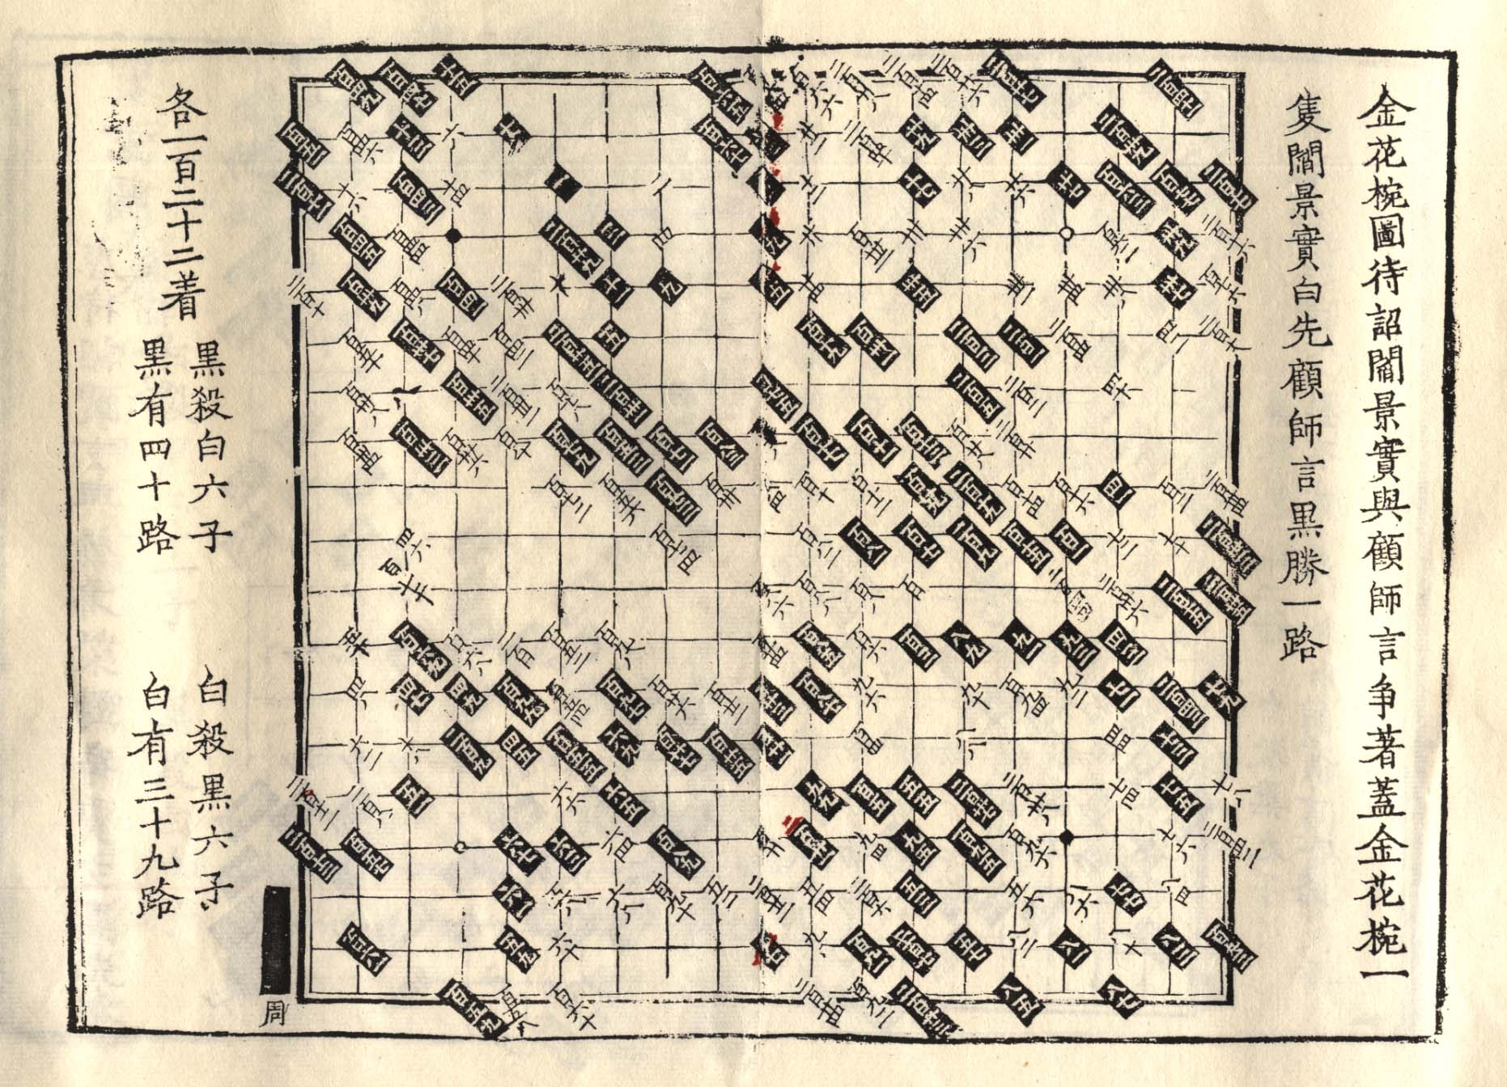
Original record of "Game for a Gold-Petalled Bowl"
The text on the right side says: "Game for a Gold-Petalled Bowl, Yan Jingshi and Gu Shiyan fought for a lidded gold-petalled bowl. Yan Jingshi was White and played first. Gu Shiyan was Black and won by one point [for which the Chinese character is ‘road’]."
The text on the left says: "122 moves by each side. Black captures 6 white stones. White captures 6 black stones. Black has 40 points. White has 39 points." The following is the diagram of the final position.
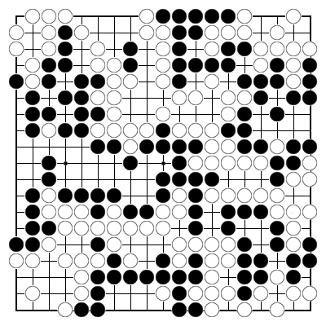
Final position in "Game for a Gold-Petalled Bowl"

Looking at the game record and the way the game score is expressed, people may feel strongly that this is almost Japanese rules. First, the dame [neutral points] have not been played, which is the most distinctive feature of Japanese rules, because the dame have no territory. Then, ”Black captured six white stones. White captured six black stones” is information that territory scoring needs. (In another game record, the Game by Four Players Together, it is even clearer: the dead stones there are to be used to "fill in".) The end result is "Black won by one point." If we use the Japanese scoring rule, the result is likewise that Black wins by 1 moku. So these rules are very similar to Japanese rules, but very different from present Chinese rules. Therein we can find the origin of Japanese rules.
But there is still a difference from present Japanese rules. Let us count. If we remove the dead stones, the Black territory is 52 points and White’s is 51. Now if we fill in the 6 dead stones, the result should be Black 46, White 45. But the game record is: Black 40, White 39, which means 6 points fewer for each side. But there are three strings of stones on each side in this game and, in accordance with the "two overflowing" principle, for each string of living stones two eye points must be deducted. Therefore, both sides must subtract 6 points. In this game, both sides have equal strings of living stones, and both subtract 6 points. That does not change the result, but the subtraction is still necessary. This is to comply strictly with "two overflowing". The other three game records are the same.
On the surface, the go rules of the Chinese Tang Dynasty were territory scoring. Essentially they were territory counting, but actually a method of stones scoring with "two overflowing". But this needs "equal stones". So where is the prerequisite? Note the phrase: "122 moves by each side", in the upper left corner of the photocopy (the Chinese character 各 means "each side").
We usually use “total 244 moves” to describe how many moves are played in a game. Let us look at two other game records: "145 moves by each side" in the “Rotted Axe-handle Game” and "119 moves by each side" in "Jia Xuan’s Game". Both say "each side", instead of "total". That is a great difference. "Each side" means the numbers of moves of Black and White must be equal, in other words, "equal stones".
Regrettably, most people cannot see the original. In versions of the C&IP published today, the description of the numbers of moves has been changed by the editors. The "Game for a Gold-Petalled Bowl" has been changed to "total 243 moves", because move 244 is not to be found in the game record. Moreover, in the game record "Game by Four Players Together" there is even the phrase "total 242 moves", so it seems natural enough to collate them all, including the other two, by changing "each side" into "total", the form we also usually use at present.
But there is obviously some doubt. Therefore, the original must be used for research. The following is my copy of the original from the National Library of China:
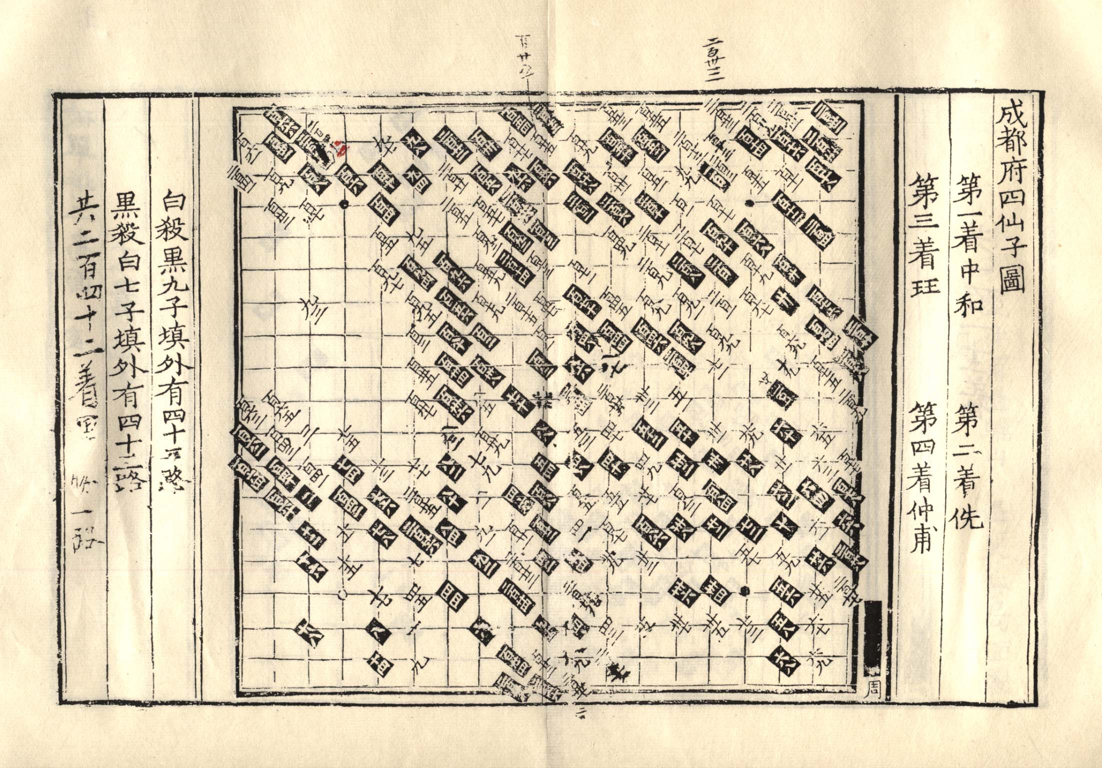
Original record of "Game by Four Players Together"

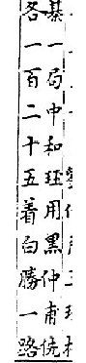
The far left line says clearly "total 242 moves". But after careful scrutiny it can be seen to have been written with a brush. That is, it was added by a later generation, and is not in the original book. In the original book, the number of moves is missing. Why didn’t it say as, in three other game records: "121 moves by each side"? The answer is found in the XXQJ in which there is no game record, but just a comment by a viewer of the game. The comment says: "125 moves by each side, and White won by one point." (see photocopy of the original on the right.)
So it is clear: in the game record collected by the editor of C&IP the last few moves were missing, in other words the game record was incomplete. And so the number of moves was missing. But in the XXQJ we still see "each side".
This shows that "each side" must be used to describe the number of moves, even if the last few moves cannot be recorded. Inadvertently the modern editing has lost extremely important information for the ancient rules of go.
Incidentally, the title "Game by Four Players Together" in Chinese is Cheng Du Fu Si Xian Zi Tu. Cheng Du Fu is another name for go, and it has nothing to do with the city of Chengdu. Do not take words too literally!
But there is still a problem. In those games, the dame have not been played. How can there be "equal stones" if the first player makes the last move to end the game? (In ancient Chinese go, it was not strictly stipulated whether the first to move should be Black or not. And of those four games two started with Black first and the other two with White first. Among those four games is "Jia Xuan’s Game".
The following is a photograph of the original:
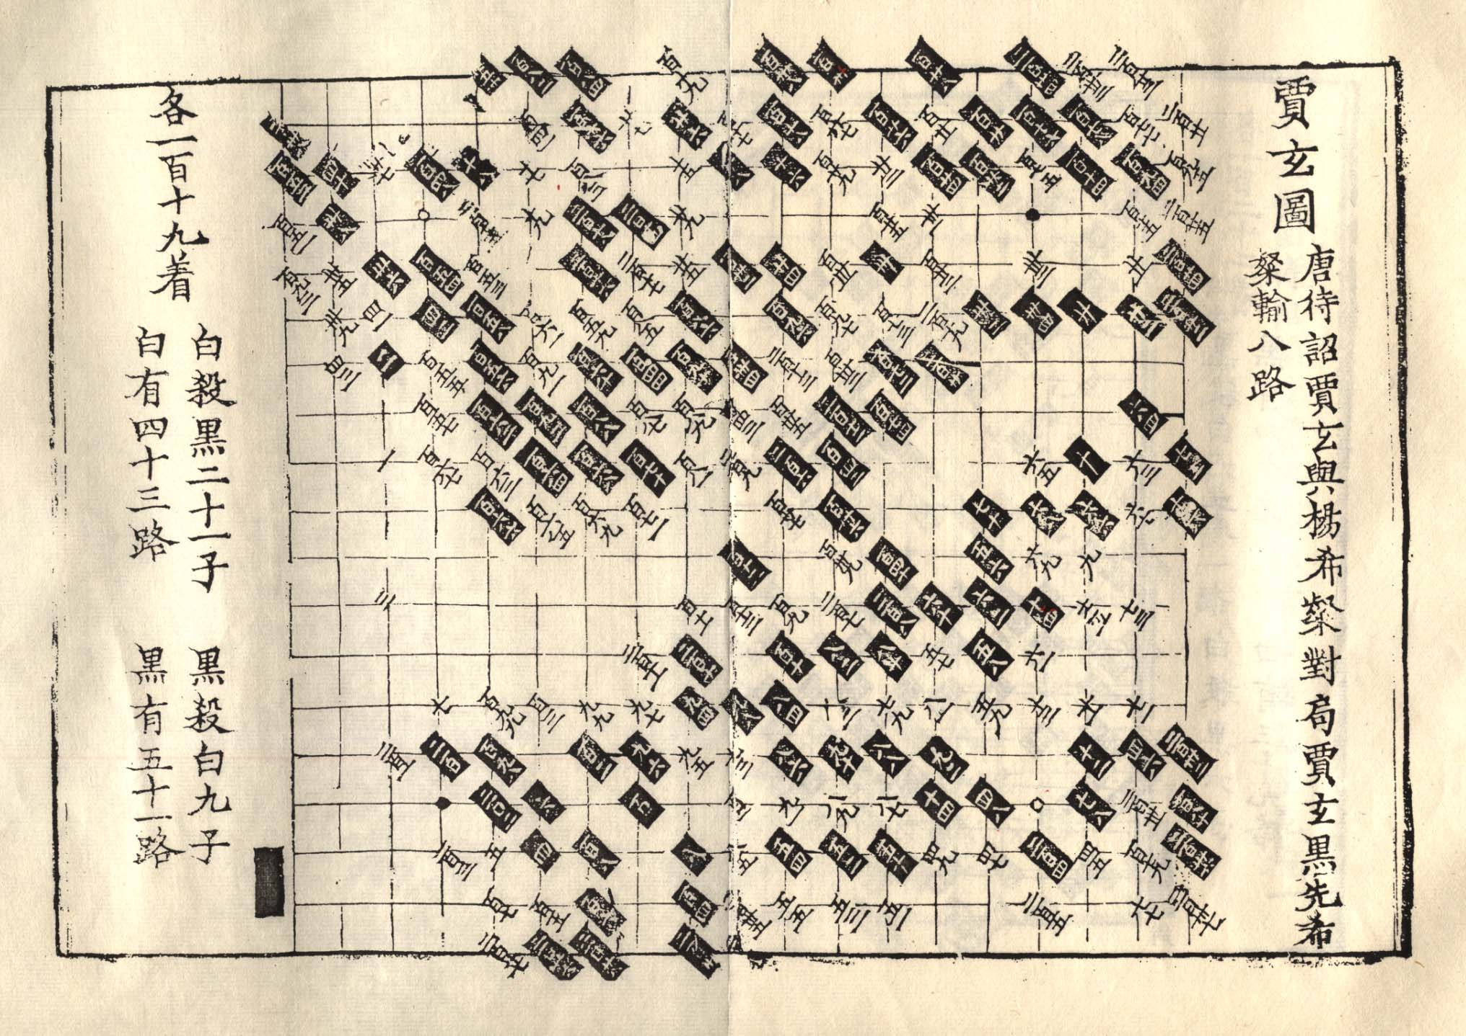
Original record of "Jia Xuan's Game"

The text runs: "Jia Xuan, Black, first. [Yang] Xican, White, loses by eight points. 119 moves by each side. White has captured 21 black stones. Black has captured 9 white stones. White has 43 points. Black has 51 points."
The following is the final diagram.
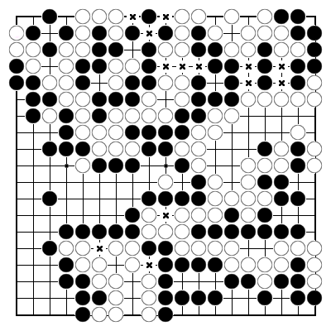
Final position in "Jia Xuan's Game"

Let us count. If we remove the dead stones, the Black territory is will be 76 points. Once the 21 dead stones are filled in, the remainder will be 55. The White territory will be 58, but if the 9 dead stones are filled in, the remainder is 49. There are two strings of Black stones and three strings of White stones, so the two sides should be deducted 4 and 6 points respectively. The result should be 51 for Black and 43 for White. White loses by 8 points. This is fully consistent with the text record.
But there are dame. The dame comprise 13 moves (marked X). Black would make the last move. So how can there be equal Black and White stones? A natural idea is White will make an additional move, that is, minus 1 point, as in AGA rules. As a result White would lose by 9. But the result is still 8, as in present Japanese rules. How can that be? A reasonable assumption is: If Black makes the last move, in order to have equal stones for each side, Black will remove his last stone. Once territory counting is adopted, dame are naturally not played. People tend to simplify habitually, so the last dame will be ignored. This probably explains why the move 244 comes to be missing in the “Game for a Gold-Petalled Bowl”. It is because it must have been a dame. In ancient go rules, compensation (komi) was not adopted, so ignoring the additional benefit to the first player to move is also very natural.
Next, the following photocopy of the "Rotted Axe-handle Game " is attached for reference, Note the Chinese character 各 ("each side") in the upper-left corner.
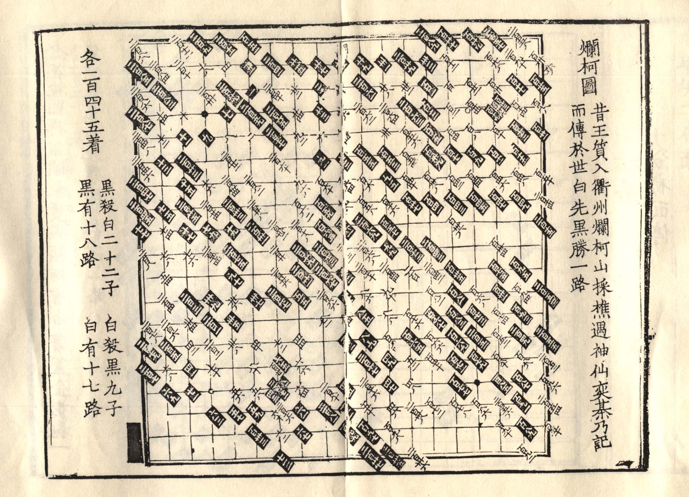
Original record of "Rotted Axe-handle Game"

From this we can draw the following conclusions:
- The rules used in Tang Dynasty China were very similar to Japanese rules, so Japanese rules undoubtedly derived from the Tang Dynasty rules.
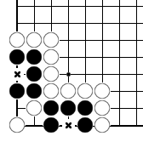
- Under territory scoring, deducting the remaining eye points is not justified, so the rules of the Tang Dynasty were not territory scoring but territory counting, the counting method being stones scoring. See the diagram at the right. According to the principles of stones scoring, the two live (in seki) points marked X cannot be counted for Black. We know that there is still such a stipulation in the present Japanese rules, although it does not comply with territory scoring. It is very discordant with present Japanese rules. However, it was inevitable under the Tang Dynasty rules which were introduced to Japan together with go. It is a living fossil of the rules during the Tang Dynasty embedded in Japanese rules. It is proof that Japanese territory counting was originally a simplified form of stones scoring.
- From the term "each side" we can see that territory scoring must be based on "equal stones". But dame are not played, and it does not matter who makes the last move. The term "each side" is often not used, so it is easy to overlook.
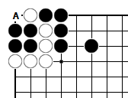
The diagram at left is an example of "three points without capturing" (Japanese torazu sanmoku). If White moves first and captures four Black stones at A, the final result is 2 points for White, while if Black goes first and captures 1 White stone at A, the final result will be 3 points for White. Black certainly would not play here, but at the end of the game White cannot avoid playing here so the result will be 2 points for White. However, the traditional Japanese Go rules call it “three points without capturing”, which means there are 3 points for White. This obviously does not comply with present Japanese rules. But by the idea of "each side", even if White moves first and there are "equal stones", the result is still 3 points for White. This shows that the original Japanese rules are based on the concept of "each side", and "three points without capturing" is its legacy.
We know Japanese rules encounter a lot of difficulties at the end of the game, but if "each side" is re-adopted, these problems would no longer exist. The Japanese rules once used "each side", namely the premise of "equal stones“, but not now. It was lost in the process of development. So the most natural way to resolve the difficulties is to restore the "equal stones" concept. When Black makes the last move, there are two methods: one is AGA rules, by which White will make an additional move, and the other is the rules of the Tang Dynasty, by which Black will remove his last stone. Both methods are possible. The World Mind Sports Games 2008 Rules of Go, which I put forward, used the latter. I explained to the International Go Federation that it is a return to the Tang Dynasty (referring to the last move).
Next, the following briefly reviews the evolution of Chinese go rules. Territory counting, similar to the Japanese rule, had been used in China for at least 800 years until the Ming Dynasty (about 1500). Territory counting is simple, but there are shortcomings. First of all, saving dead stones may often be wrong, or even cheating. Second, by not playing out the dame, some potential changes due to the dame were covered up. Formal games tend to finish the dame. So around the mid-Ming Dynasty, a new way of counting was invented: unilateral stones-counting on the overall 361 points. The total number of points on the board is 361, and we can count the total number of the stones and empty territory by one side, and compare it with the number 180.5. To be sure, eye points will have remained discounted, and in practice the score will have been amended with the difference between the numbers of both strings of living stones. This is still a method of stones scoring in accordance with "two overflowing". But it must be noted that the methods are not mutually exclusive. The old territory counting is still used today: Chinese players use it to calculate the value of boundary plays in the endgame and to appraise the situation. Only at the end of the game is unilateral stones-counting used for the game score.
This rule was in use for about 400 years in China. About a hundred years ago, it was changed. Since the total number of the board's points is the target for the game score, that is the area rather than stones, the area concept was rather complete, but then to take into account the number of strings of stones not only causes inconvenience, it also undermines the integrity of 361. So it was naturally abandoned. Then there is the present Chinese rule: area scoring. As in Japan, it is counting the empty points, and so subtracting 2 points for each string increases the inconvenience and undermines the integrity of the territory, Therefore this "group tax" was naturally abandoned as well. Of course, the omission was much earlier in Japan. China must have learned from Japan!
A history of Go rules, in fact, is a history of relations between methods and the nature of go. The principle that "the side with more stones is the winner" has produced some different methods of implementation. The methods were originally meant to express the nature of go, but as the methods are more familiar to us than the nature of the game, they may gradually obscure the latter or even go beyond it. So the nature changes, and the method becomes another rule.
Territory counting on the basis of “equal stones” originally used to represent stones scoring, but territory counting is direct and apparent, while the precondition of “equal stones” is hidden. The apparent is stronger than the hidden, so, gradually and naturally, dame came not to be played and eye points not to be deducted. The precondition is not just hidden; it is lost. People are only concerned with empty points, so territory counting gives way to territory scoring, which is the present Japanese rule.
In order to achieve unilateral counting and compensate for the 361 points, eye points should be counted, and that becomes area scoring. It later evolved into the present Chinese rule.
The ancient go rule that "the side with more stones is the winner" has generated two methods which have evolved into today's two rules: the Chinese rules and the Japanese rules. That is basically the evolution history of the rules of go.
Compared with the original stones scoring, the Japanese rule dismisses two conditions: "two overflowing" (i.e. subtracting eye points) and "equal stones", whereas the Chinese rule cuts out only the "two overflowing" principle. Cutting out "two overflowing" will not cause any problems, but abandoning the "equal stones" concept will bring about a logical paradox, leading to various defects.
Aware of this history, we can see that it is impossible to resolve the deficiencies of Japanese rules by avoiding "equal stones" because the deficiencies were originally generated by the loss of "equal stones".

