**A Form of Tibetan Mig-Mang From the West?**

By Peter Shotwell

When I was in Tibet in the early 90s, I investigated Tibetan Weiqibut neglected to pay any attention to a second game also played on the same board with the same stones, which I assumed was just a “country” game that came from China and was just like many other Chinese pebble games. It was like studying chess and ignoring checkers and, unfortunately when I became interested, access had been cut off and since then I have been unable to find a living player of the game. Yet there are three separate accounts, one by a native Tibetan, the other by an anthropologist and a dubious one by R.C. Bell in *The Board Game Books* which will not be discussed here. There have also been numerous attempts by Western game players to formulate rules on the Internet, but except for a couple of academic studies, these are all bogus.

Both games are called “Mig-Mang” (which is often misspelled as “Ming-Mang”) and this name comes from the “many eyes” that the Tibetans see on the boards. It is certain that Weiqi came to Tibet from China, but I think there is a strong possibility that the other one came from the West. This is because the second game features “custodian capture—any stones caught between two of the other player are captured.

  

*This and this but not this*

China has many games that are played with go-like boards and stones but none that use custodian capture. There is one in Japan called Hasami Shogi where one version is played on bigger boards with go stones, but this is more related to the chess family—the sides line up facing each other at the beginning, so it is like a battlefield—and it seems unlikely that there is any relation to Mig Mang.

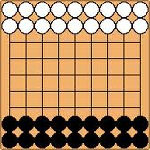

*Dai Hasami Shogi*

In the West, it’s a different story and after some investigation, I came to a speculative conclusion that the second form of Mig Mang was much more than just a “country game,” and that its heritage had nothing to do with go. Instead, perhaps it has everything to do with a lineage of custodial capture games that may go back to ancient Egypt and certainly appeared in Classical Greece and spread throughout the Roman Empire and Scandinavia until medieval times. With some possible evidence from a study of the origins of Chess, it was easy for me to speculate that it could have passed through or from Grecian-dominated Bactria into nearby Tibet at an early age.

The Greek game was called Polis or Poleis (“Cities”) and Plato says that “it came from Egypt” so there has been speculation that it evolved from Seega, an Egyptian game. However, there is no evidence that Seega was played then, though later on it gained wide popularity in Egypt and throughout the Middle East. Both games use a grid and stones with custodial capture. However, perhaps Seega was a poor man’s game played only in the dust, while Senet—another board game often played with the dead in tombs—was for the rich and so its elaborate sets were preserved therein. This may parallel the situation with Weiqi and Liubo in China—the latter was used in divination and survived in the tombs while the other would have been “just a pile of stones” on an undistinguished grid.

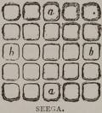

*Seega—the center square is empty and the players put down stones*

*to fill up the rest of the board and then try to capture each other*

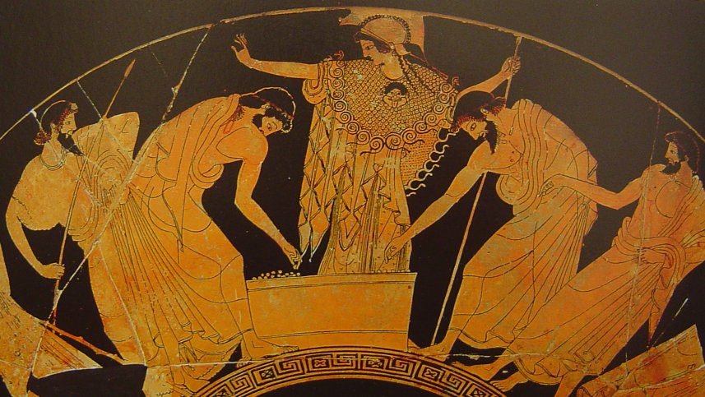

*Athena watches as Achilles and Ajax, dressed*

*as spear-carrying hoplites, play a game of Poleis.*

*They are consequently doomed to soon die in battle.*

*To the left, there is a pile of stones on the board.*

The Roman Empire had Ludus Latrunculorum or Latrunculi, also played on a grid with stones.



*The Stanway “Doctor’s Game Set” mistakenly*

*thought to be Latrunculi.*

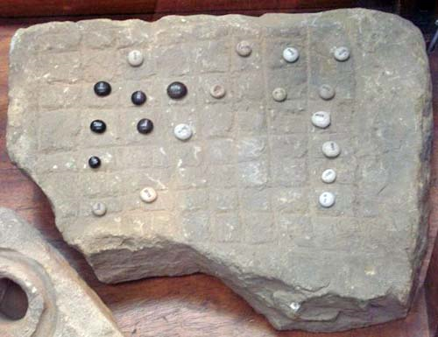

*An unknown game from Britain.*

The Vikings had Hnefatafl, played on a 19x19 board which was one of a group of asymmetric custodial capture games with the distinct feature of unequal sides with unequal goals, opening positions and a superficial resemblance to a go board. In this one, a besieged king begins in the center and must escape to the sides or corners.

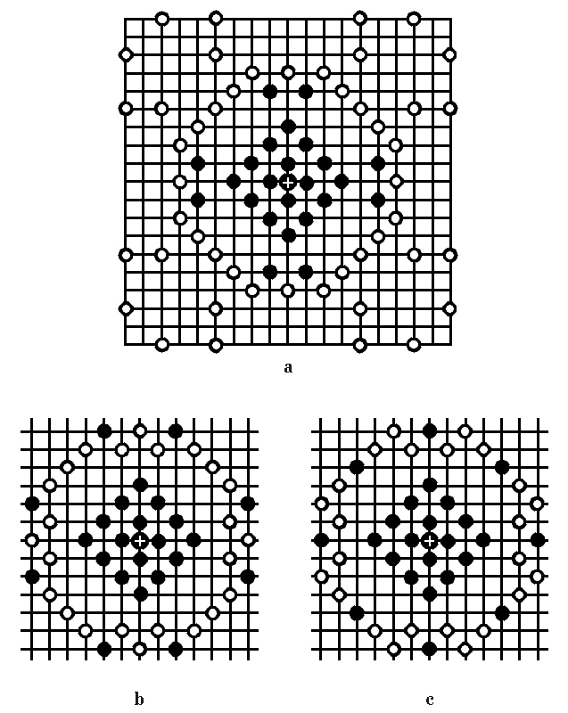

Could it, therefore, have resulted from a Middle East spoils-of-war go set ending up in Scandinavia where, not knowing the rules, they made up a new game perhaps based on earlier asymmetric Irish and Welsh games and added the ideas of a hunted king and the necessary sacrifices of defenders to clear the escape path? Since all the pieces behaved like bishops or rooks in chess (except the king, who could only move one square at a time), this must have been a most exciting game for the slaughter-based Viking culture!

We know that this lineage of games was played with custodial capture on grid-like boards using go-like stones and that dice was not used. However, with the exception of Seega, which is played today, almost nothing else is known other than that the Greek and Roman games were out-and-out military battles involving massing armies with no starting positions and where being “isolated” was often fatal. However, as in Mig Mang, there is an open question as to whether pieces moved like rooks or one space or one intersection at a time.

In any case, my thesis is that Mig Mang, being a pebble-and-board game that uses custodial capture may be related and that it came to Tibet through Bactria in Central Asia.

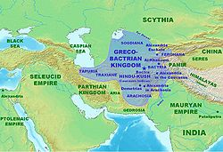

Bactria was conquered by Alexander the Great and became an independent Grecian kingdom in 246 BC. Before and thereafter, it was the conduit to Tibet for Persian Dualism, Indian Buddhism and the mercantile products of the Silk Route. Myron J. Samsin, a German researcher, wrote *Pawns and Pieces: Towards The Prehistory Of Chess*, <http://www.mynetcologne.de/~nc-jostenge/>. He noted how the important role Poleis played in early Greek society should have remained the same in Greek-speaking Bactria and other areas of their diaspora. Once that is established (despite the fact there are no archeological discoveries as of yet), he demonstrated how pawns in chess, because they are so different than the other pieces, may have evolved from the custodial capture principles of Poleis pieces. Thus:



*The net effect of a capture in Poleis*

*and the resulting capture in chess*

Simins suggests that these pieces and their moves were attached to an Indian dice game called Siga (no relation to the Egyptian game) that was discussed by H.J.R. Murray in his 1913 *A History of Chess* and that this ultimately resulted in chess.

As for Mig Mang, in the two descriptions, it is agreed by all that the Tibetan custodial capture game began like this:



The pieces move to the center and captured pieces are replaced by those of the capturer, but that’s about all we know. For example, in the Dominikus Schoder’s German translation of the Chinese anthropologist Jen Nai-Ch’iang’s *Die Fandse*, a study done in Cham, it says that the stones on the sides cannot be captured, however this is not in the original Chinese. And, a Tibetan woman, Rin-Chen Lhamo, writes and illustrates capture on the sides in *We Tibetans*,

*The longer the sequence you can* [capture] . . . *the better and the sequence is not broken by going around a corner, thus:*



However, this book was by an English-husband and Tibetan-wife team who communicated with each other in Chinese, so “going around” is ambiguous (and even more so in Chinese), therefore whether this rule applies to any place on the open board is a mystery.

And there is more mystery at the end. If a player has only one piece left, she writes:

*. . . this acquires the additional power of taking pieces by hopping as in draughts, so that, to prevent this, it has to be closed in on each side by two pieces instead of one: it is thus possible to win, even when reduced to this desperate position, but of course most unlikely.*

There is also the old question in this lineage of whether the pieces move one intersection at a time or like that of a rook. The former is very slow (the anthropologist spent a while playing one game with no result) while Rin-Chen Lhamo says nothing about this subject. However, the mannar in which she describes it indicates that the games were quick and there the pieces could move more than one intersection at a time.

In Jen Nai-Ch’iang’s report, we find this situation at the end of a supposed game:

 

*In his translation, Schroder handwrote the word “Checkmate!”*

*next to this mysterious diagram . . .*

  

*. . . which, although it is not stated, can only happen if we replace the captured stones marked with an X with white stones and make the move W1. Note how the single black stone has been hemmed in and also, that there are 34 (and not the proper 32) stones on the board.*

There is nothing that Black can do. Any of the pieces on the left can be captured if they move and the other black stones are immobilized. This is the same end that Plato wrote about that befits

*. . . bad petteia players, who are finally cornered and made unable to move by clever ones . . .”*

And a Tibetan informant once told me that trapping and complete “capture” is how games can end. But I am still looking for someone who has actually played the game . . .